**Snort: An Essential Intrusion Detection System**

Introduction:

Snort is a widely-used open-source intrusion detection and prevention system that plays a crucial role in network security. In this article, we will delve into the features and benefits of Snort and provide a detailed step-by-step guide on how to install Snort on both Windows and Linux operating systems.

I. Understanding Snort:

Snort is an Intrusion Detection and Prevention System (IDS/IPS) that helps protect networks from malicious activities, such as network scans, unauthorized access attempts, and other security threats. It utilizes various detection methods, including signature-based, anomaly-based, and rule-based techniques, to identify and alert administrators about potential security breaches.

II. Benefits of Snort:

Open-source: Snort is freely available and customizable, allowing users to adapt it to their specific needs.

Efficiency: Snort efficiently monitors network traffic and provides real-time alerts, enabling quick response to potential threats.

Flexibility: Snort can be deployed in various network environments, from small home networks to large enterprise setups.

Community support: Snort has a vibrant and active user community, providing regular updates, rule sets, and support.

III. Installing Snort on Windows:

Download Snort: Visit the official Snort website and download the latest stable version compatible with your Windows operating system.

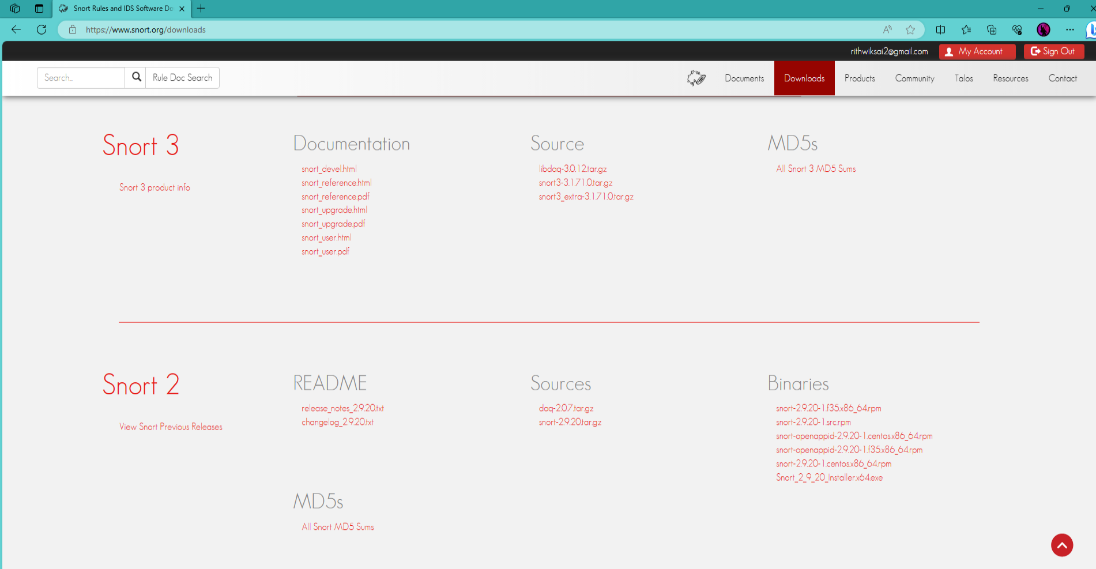

Select the Snort_2_9_29_installer64.exe

Then install the rules

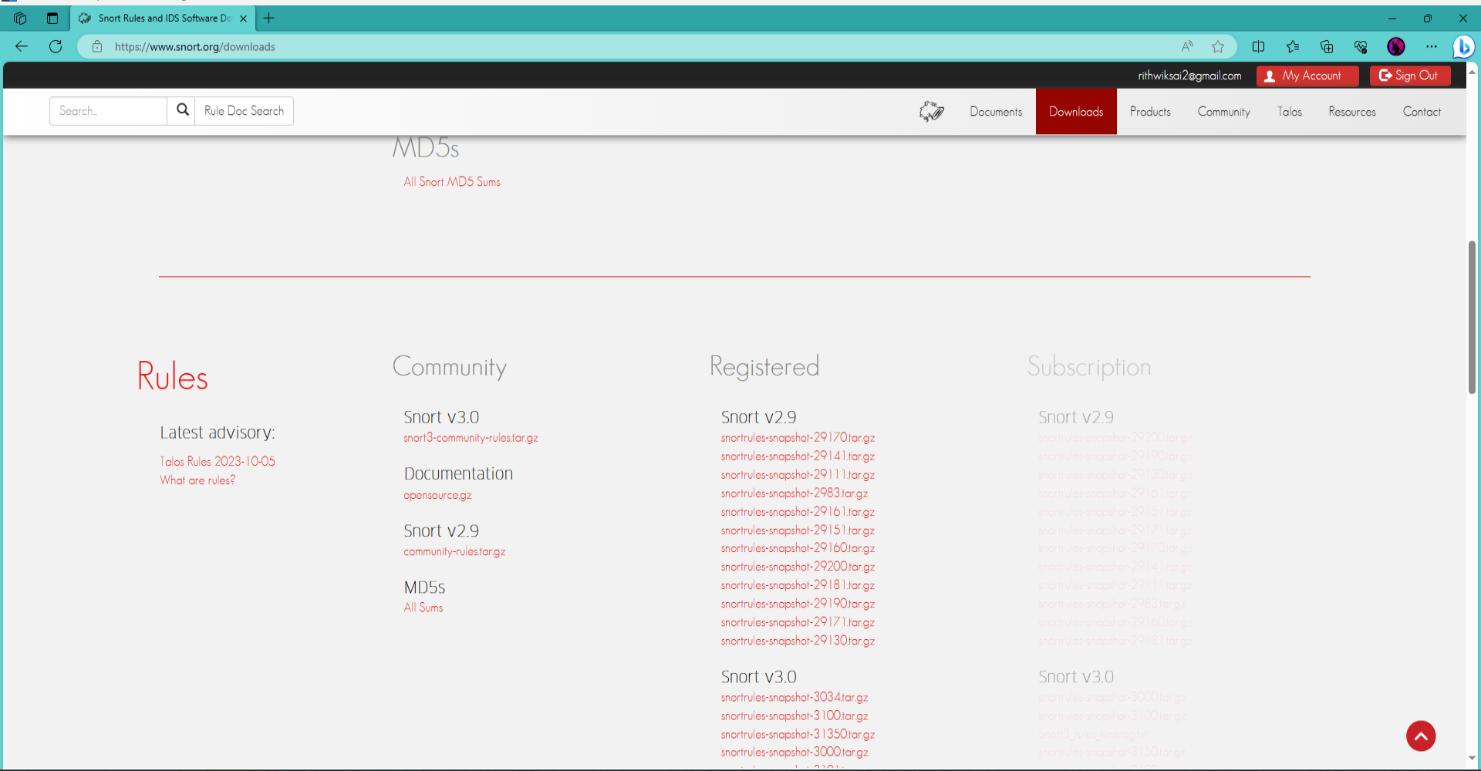

Select the lates one in Snort v2.9.

Then run the installer.

Extract and copy the snort rules into the snort

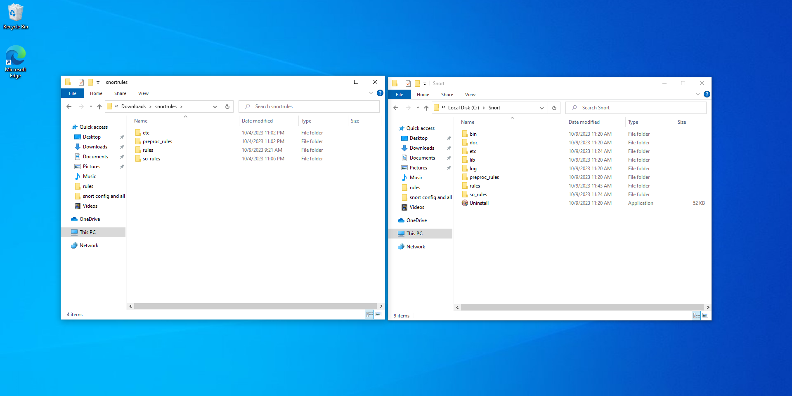

Install WinPcap: Snort requires WinPcap, a library for capturing and transmitting network packets. Download and install WinPcap from the official website.

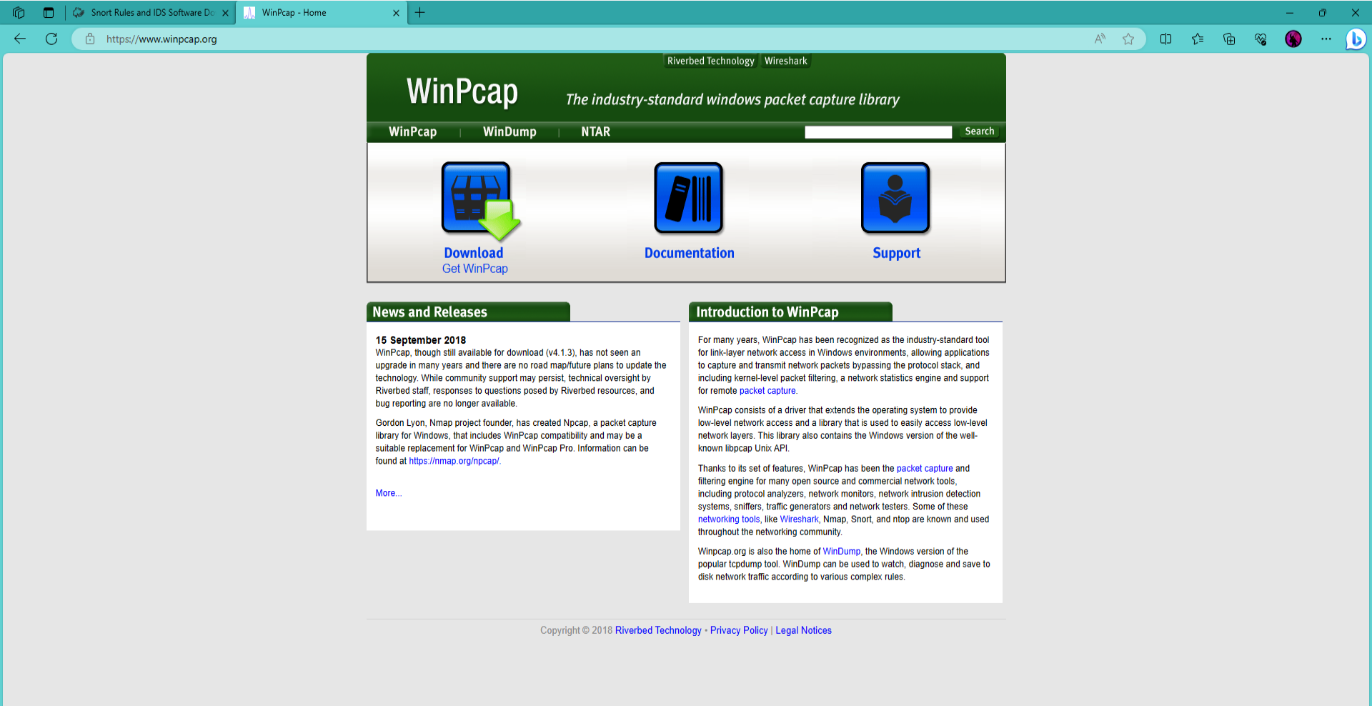

Run the installer.

Configure Snort: After installation, locate the Snort configuration file (snort.conf) and modify it according to your network requirements, such as network interface, rules, and logging settings.

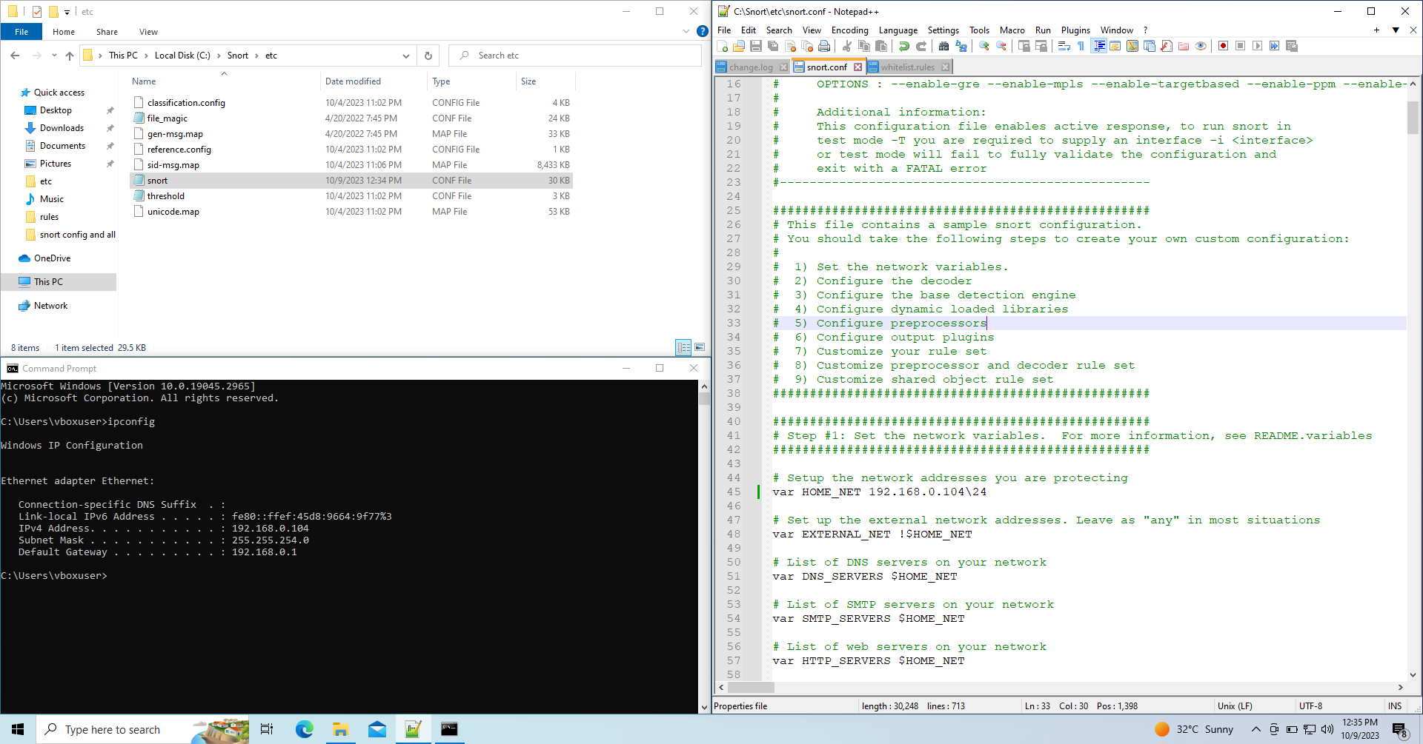

Open snort.conf with notepad or notepad++

Change Ip address in line 45 to your Ip

To know your IP open command prompt and type ipconfig

Copy your IP and paste in line 45 in snort.conf

Give the path to rules and preproc_rules in lines 105 and 106 respectively

Also copy the blacklist folder in rules folder in snort and paste it and change name to whitelist

Also give path to black list and white list in lines 109, 110

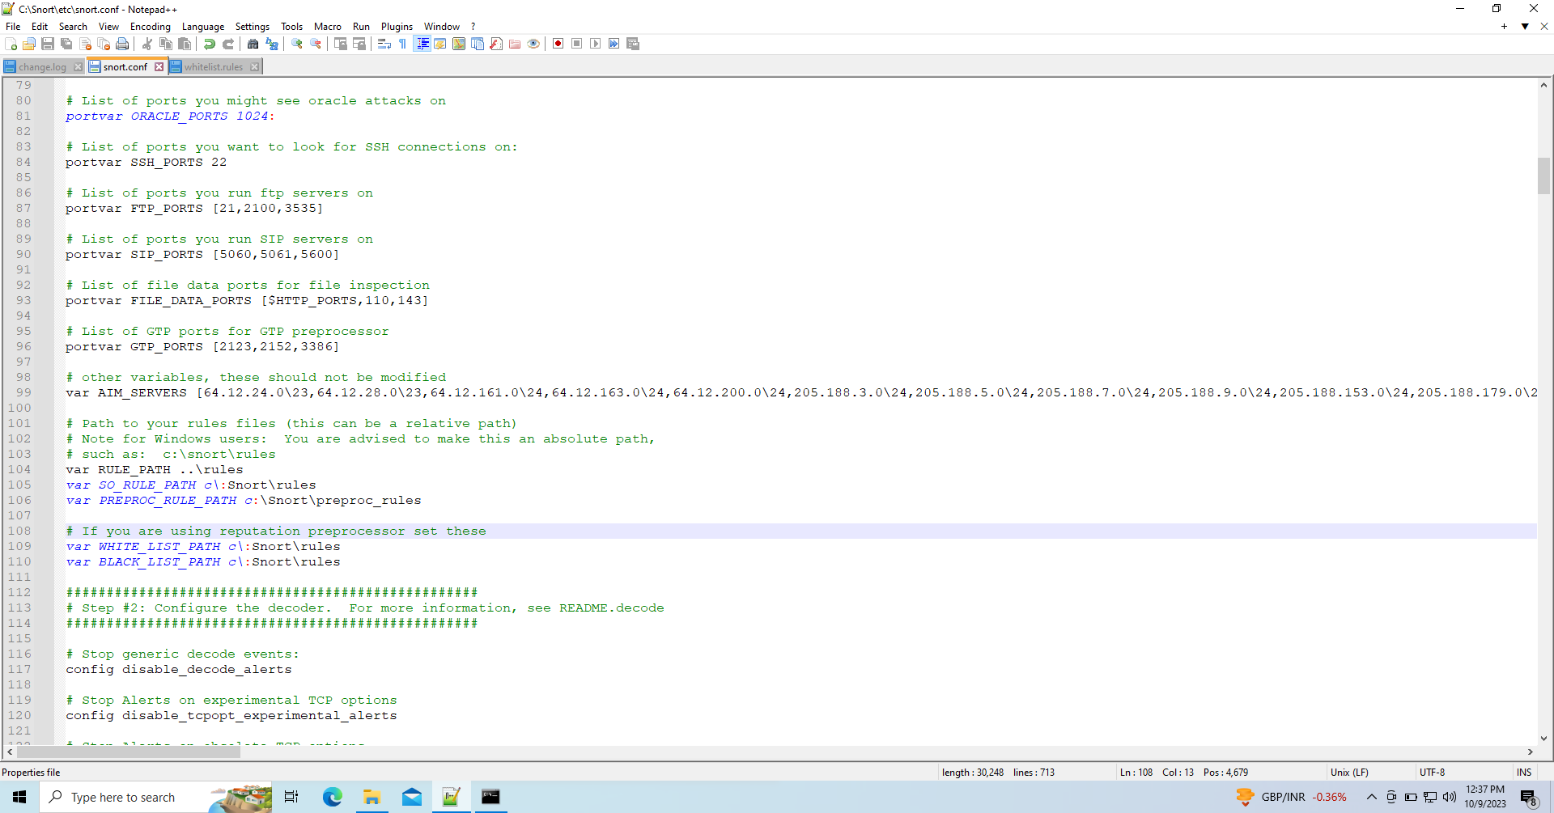

Give path to log dir in line 182

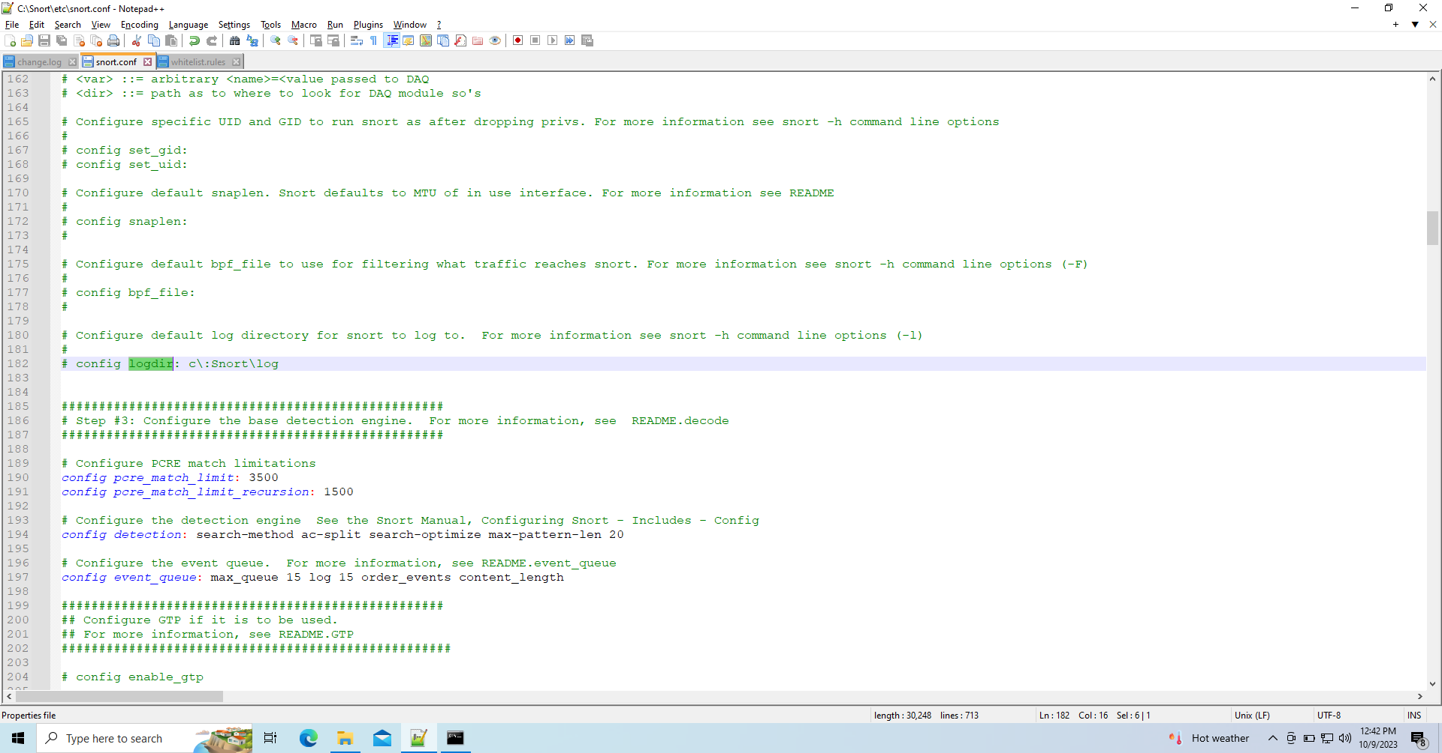

Give paths to dynamicpreprocessor directory and dynamicengine in the lines 243,246

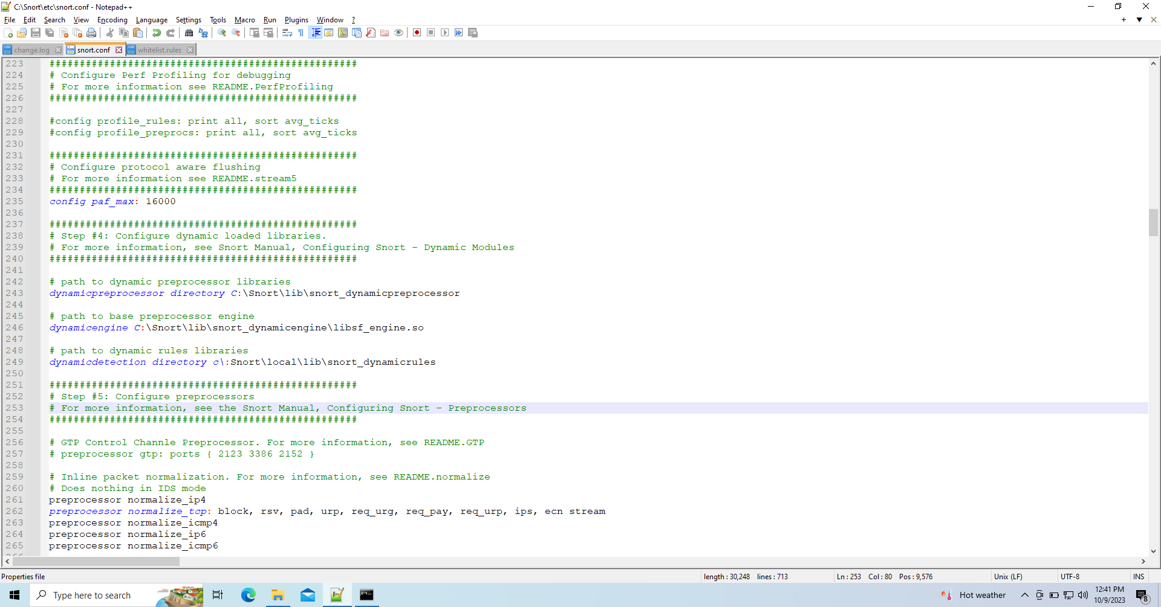

Save the file.

Test Snort: Run Snort in the command prompt with the appropriate parameters to test its functionality and ensure it is properly configured.

Give direct path to snort by going into view advanced system settings in windows, then environment variables, click on path and give new path as c:\Snort\bin

Click okay for all

Now go to command prompt and enter snort

IV. Installing Snort on Linux:

Update system packages: Open a terminal and run the package manager update command to ensure your system is up to date.

Open terminal and enter sudo apt update and let it update

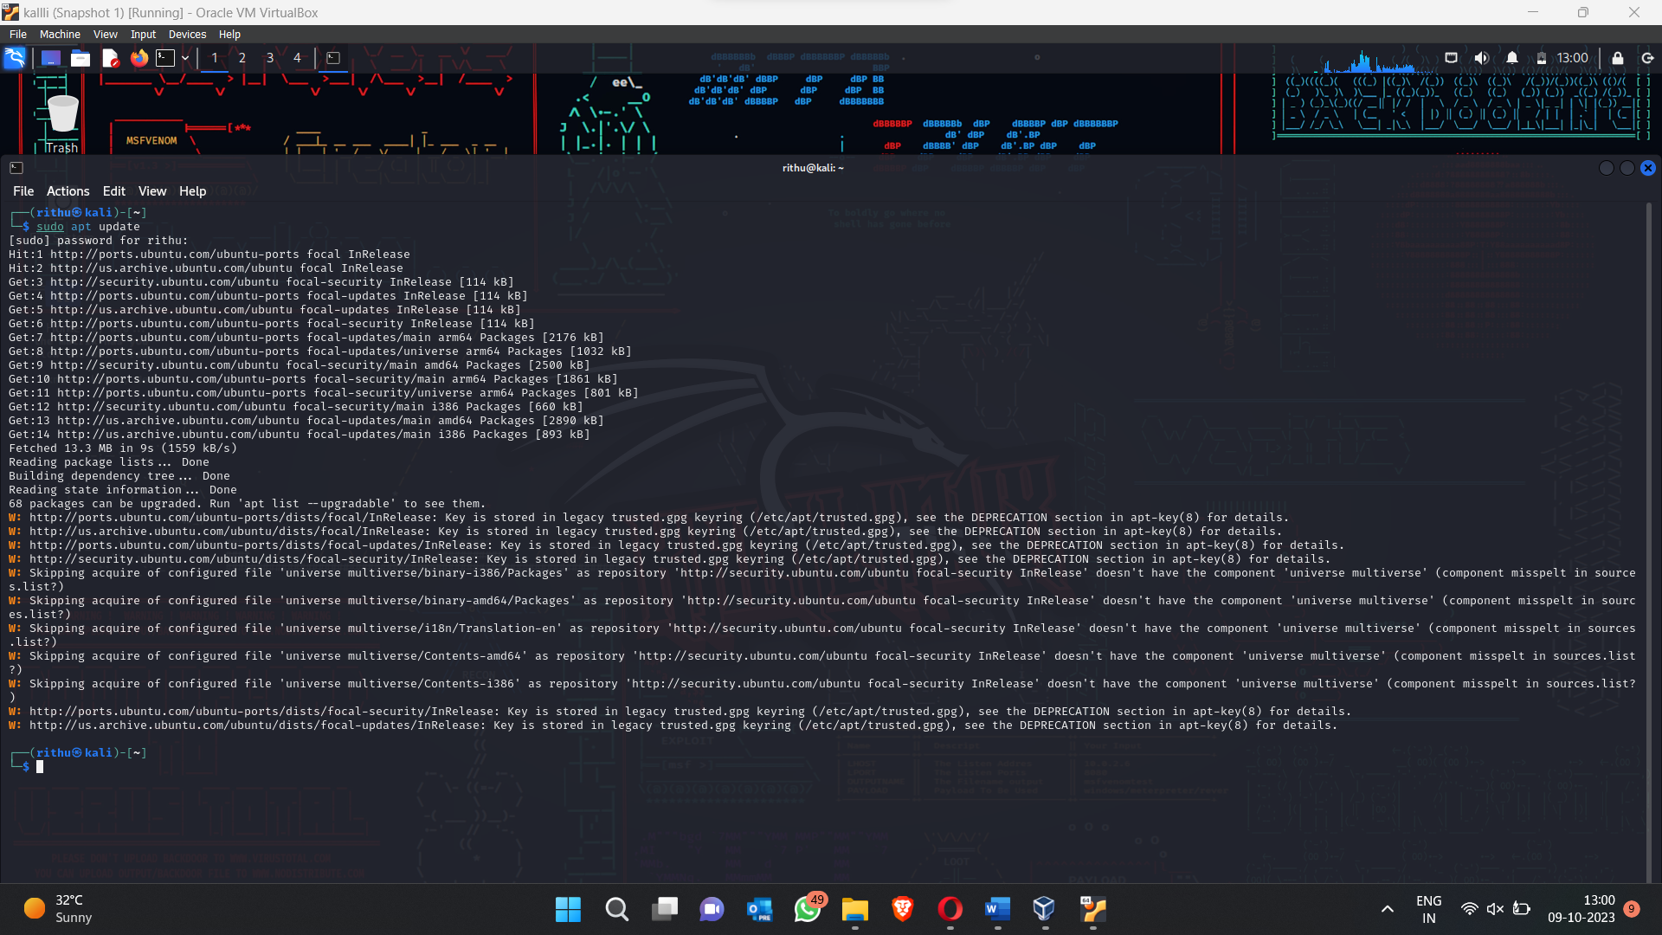

Install dependencies: Install the necessary libraries and packages required for Snort to run smoothly.

Download Snort: open terminal and type sudo apt install snort

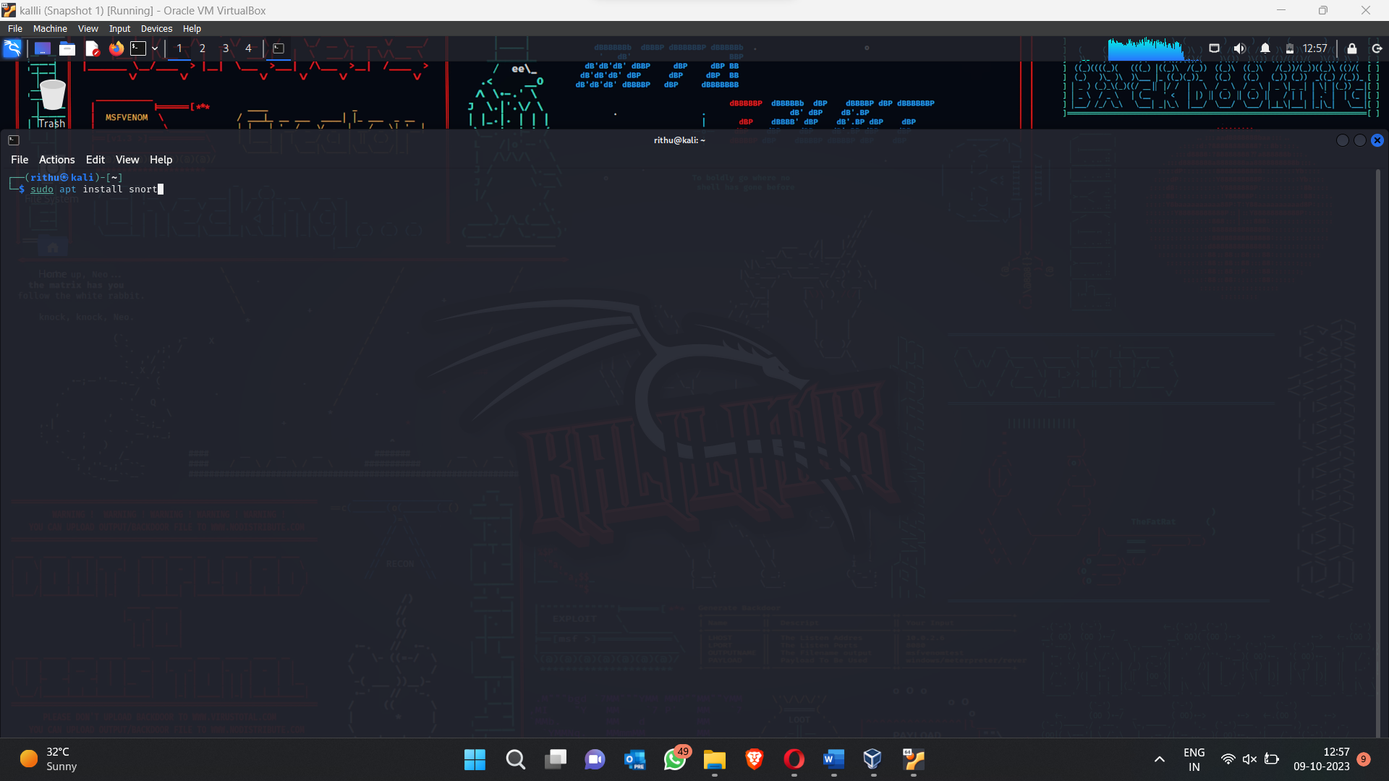

Write rules:

Open terminal and enter sudo nano /etc/snort/rules/local.rules to write any rules in it

To close click ctrl+x

Start Snort: Run Snort in the terminal using the appropriate command, specifying the configuration file and network interface.

sudo snort -i eth0 -v

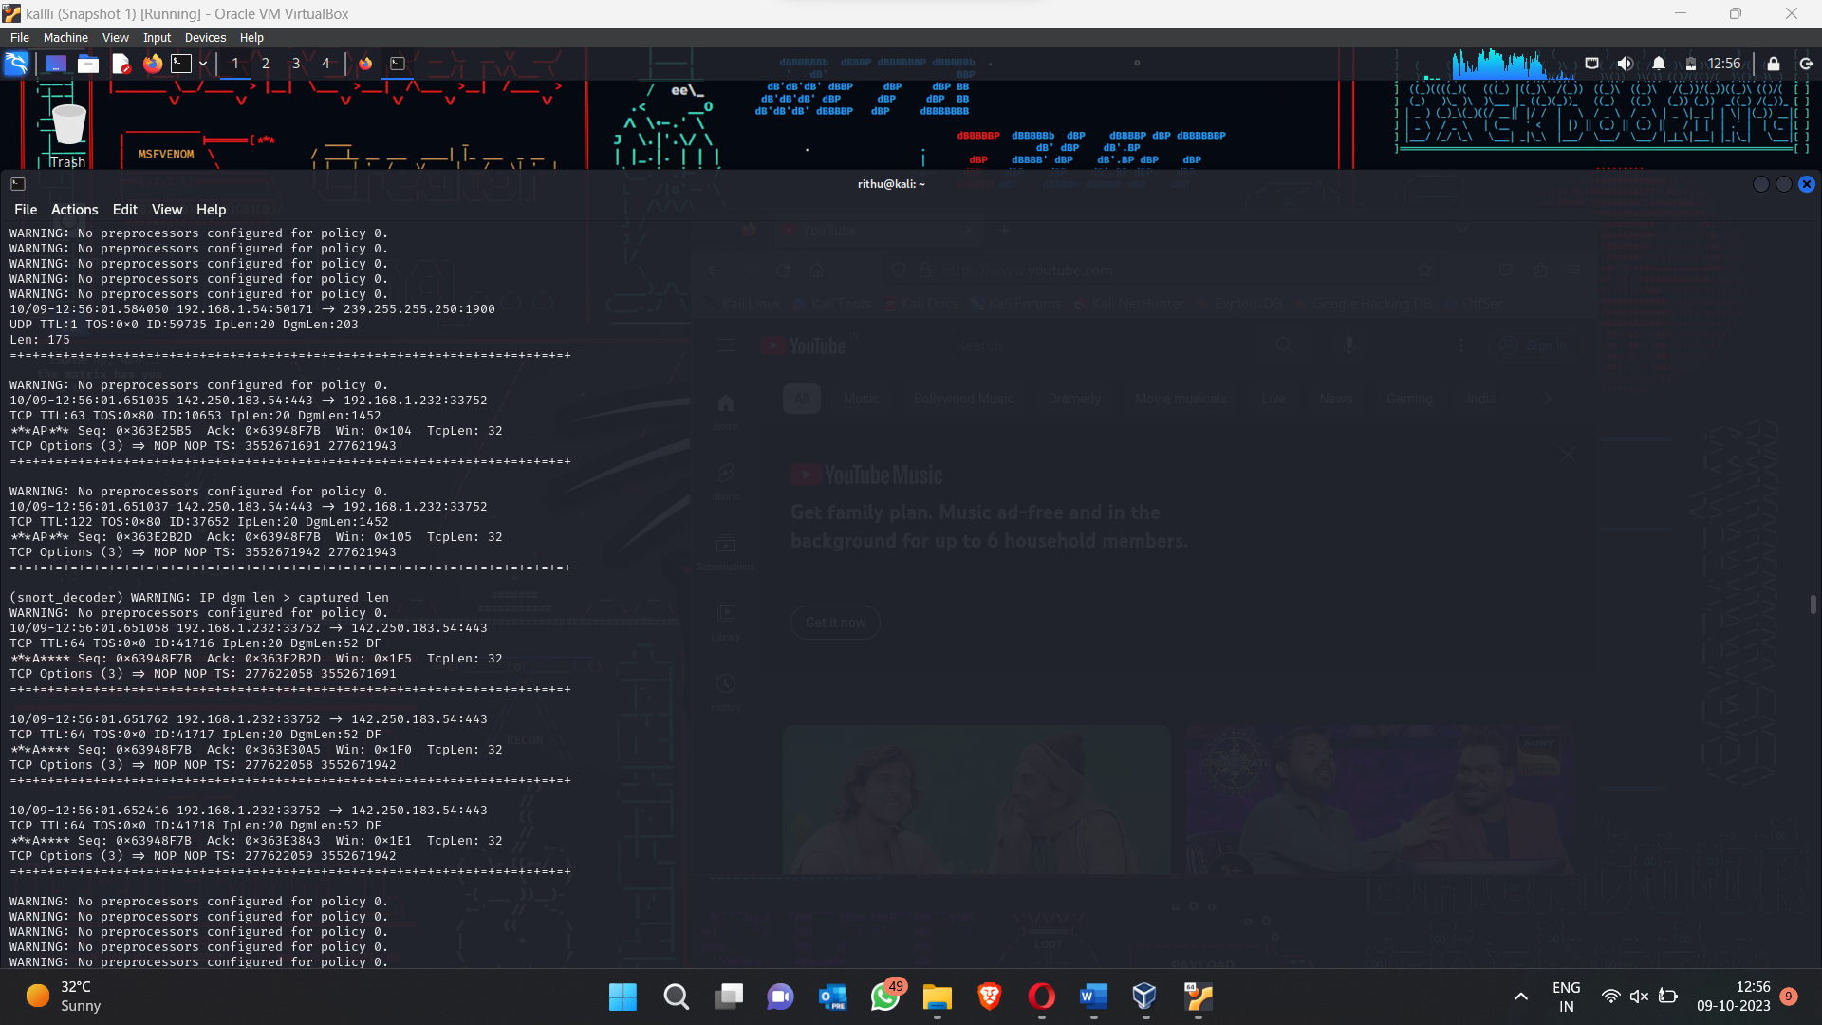

Conclusion:

Snort is a powerful and versatile intrusion detection and prevention system that aids in safeguarding networks from potential security threats. By following the step-by-step installation guide provided in this article, you can successfully set up Snort on both Windows and Linux operating systems. Remember to regularly update Snort and its rule sets to ensure optimal performance and protection for your network.

Please note that this article provides a general overview and installation guide for Snort. It is always recommended to refer to the official Snort documentation and consult specific resources for more detailed instructions or troubleshooting assistance.